COMP 10001 Programming Fundamentals
Assignment 1 – Problem Solving

Question 1: Solve the puzzle

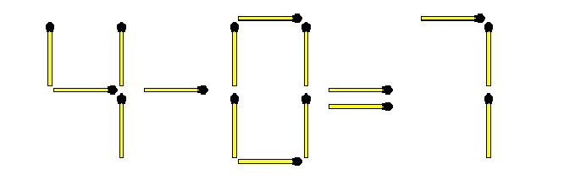
Solution

1) Add 1 matchstick to the top of the 4
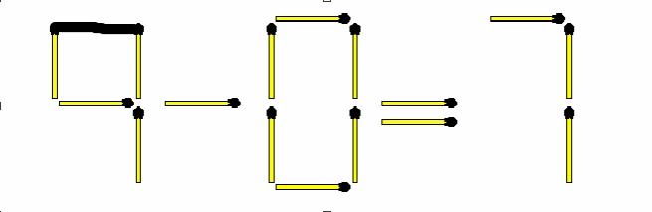

2) By using 1 matchstick make Minus sign(-) into Plus sign(-)
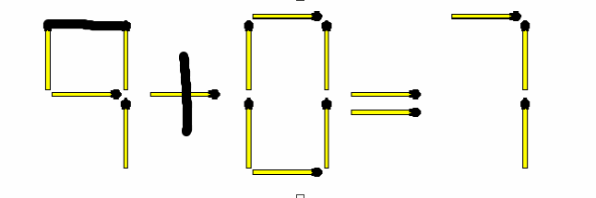
3) Now by adding 3 sticks we can make 9 from 7

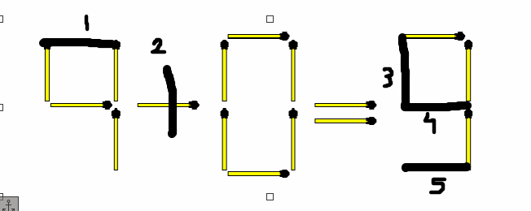
Now 9 + 0 = 9, which is true

How I get to the Solution?
- I used trial & error technique to solve this problem, I just started out the problem in spite of wasting a lot of minutes to get to the idea; as this problem is not too complicated I came to the solution instantly

- Even analogy technique helped me here, as I have solved many similar problems in past like other matchstick problems, Sudoku, Chess, and more...

Question 2: Grid Puzzle

Solution

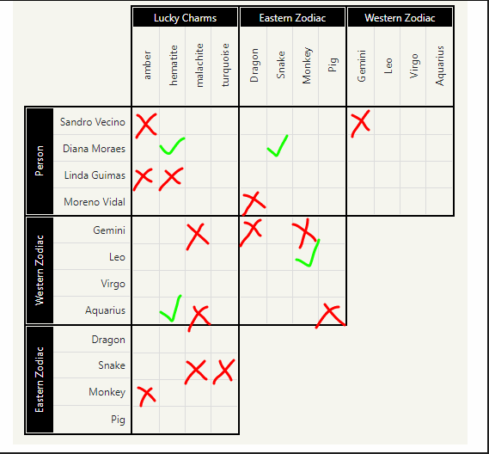

1) The person born in the year of the Monkey is also Leo.
-now we know that a person born in the year of Leo is also Monkey

2) Linda’s stone is either the malachite or the turquoise
-meaning Linda can’t have amber and hematite

3) Diana or the person who is Aquarius is wearing hematite
- So Diana is a potential candidate for answer

4) Monero wasn’t born in the year of Dragon
- So Monero can’t be the Dragon born
5) The Leo or the Virgo is wearing Malachite
- So Gemini and Aquarius can’t wear Malachite

6) The Gemini was born in the year of Snake and Pig
- Meaning he/she can’t be born in the year of Dragon and Monkey

7) The Aquarius wasn’t not born in the year of Pig
- So that’s straightforward

8) The person born in the year of Snake either wears Amber or Hematite
- So the person born in the year of Snake can’t wear Malachite or Turquoise
- Diana might be Snake

9) Sandro doesn’t wear Amber or born in Gemini
- That is straightforward

10) The person born in the year of Monkey doesn’t wear Amber either
- That is straightforward

According to me, Linda can’t be wearing the Hematite, now its just Diana, Sandro and Monero. The chances of Sandro and Monero of wearing isn’t mentioned directly.

However, it is stated that either Diana or someone else is wearing the Hematite.

